AI for Non-Developers: Install instructions

Create Github account
- https://github.com/signup
Navigate to GitHub at the url above. Sign up for an account with your Improving email address. Once you have an account, please post the account name into the meeting chat.

Log into Windsurf
- https://windsurf.com/profile
Navigate to Windsurf at the url above. Once there, select “Continue with Devin”.
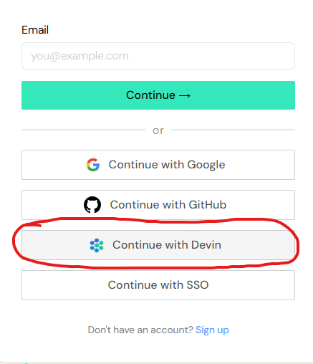
Sign in with your Improving email. If you see the following screen, click “Improving” and you are good to go.
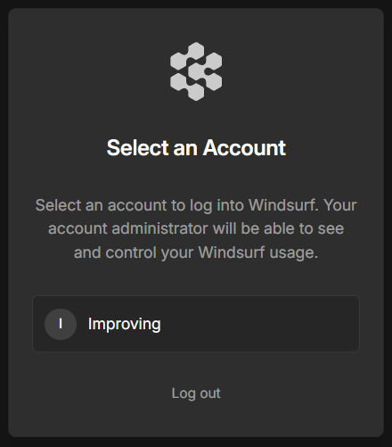
Otherwise, you may see a message that no account is found. That means you have not been granted access yet. Continue on with the rest of the directions and pay extra attention to the backup plan step.

Install necessary software

Windows users
Windows thankfully comes with a built-in software management system called winget. You will install the following software by opening a terminal than pasting/typing in winget commands.

Open the windows menu and start typing terminal. Open the terminal app.
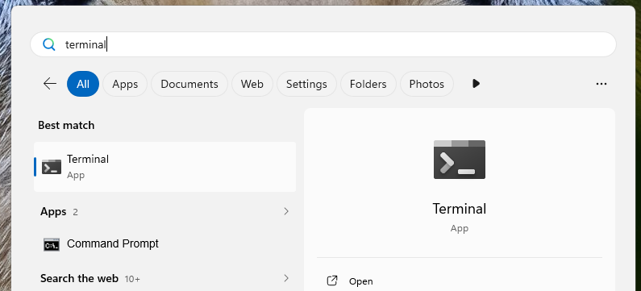
You should see a terminal window:
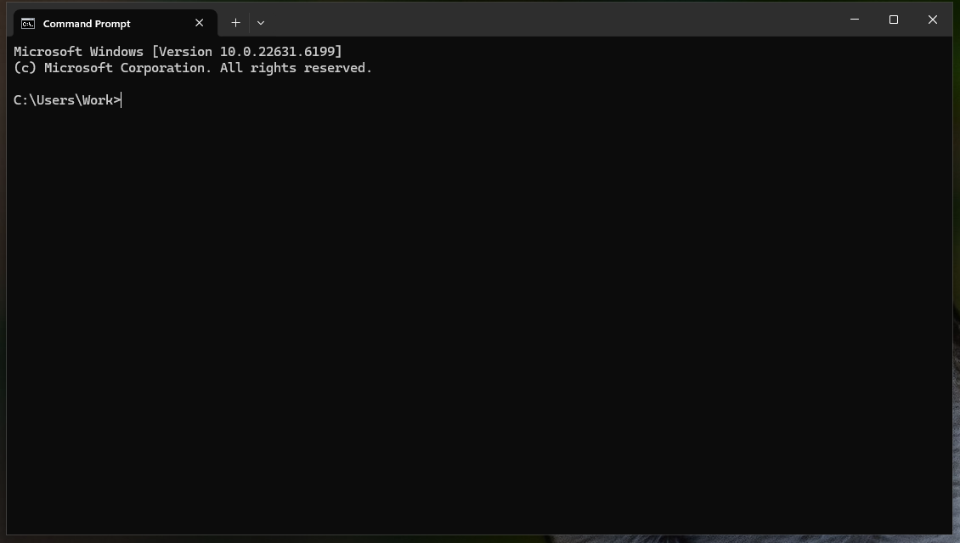

Git
Once in terminal, type/paste the following command to install Git:
winget install --id Git.Git -e --source winget
Git will install and you will see a request for administrative privileges (yours may be a full screen alert). Click yes.
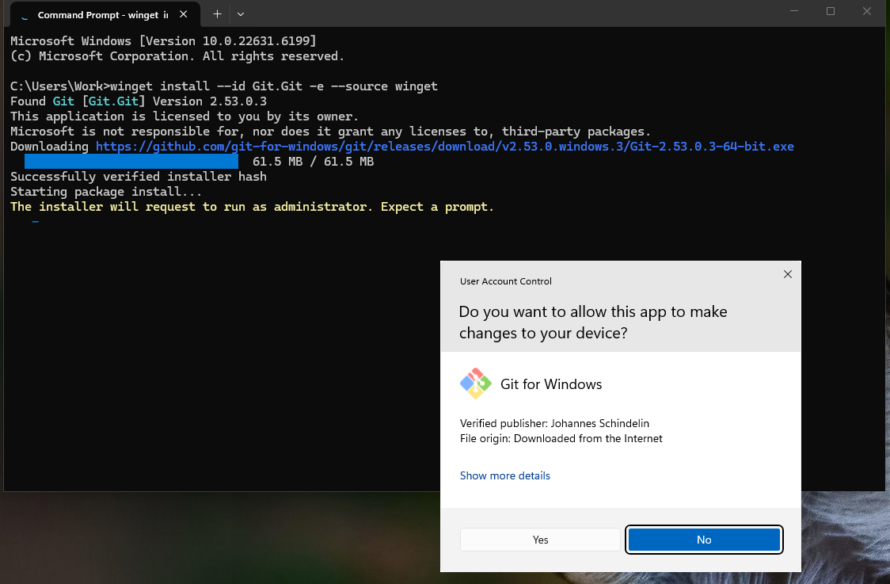

Windsurf
In the same terminal or a new one, type/paste:
winget install --exact --id Codeium.Windsurf
Windsurf installs per user so you should not see an administrative privileges prompt.

Mac Users
Mac does not come with a built-in software management system, but there is a well-supported one that is easy to install.
Open spotlight search (command-space) and start typing terminal. Open the terminal app.
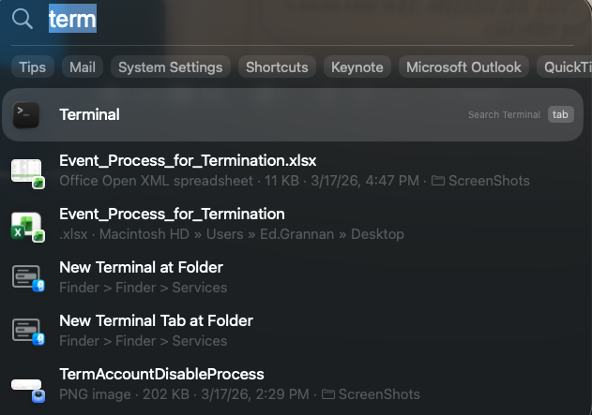
You should see a terminal window:
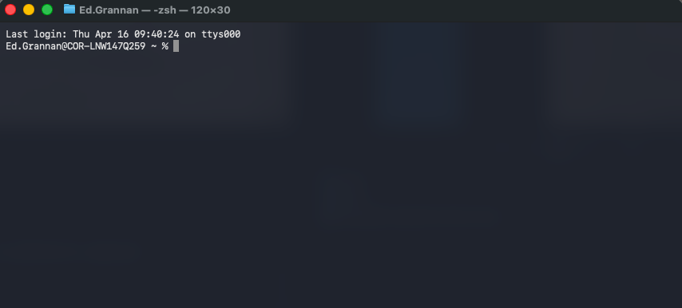

Brew
Paste the following command into terminal to start the installation of Brew:
/bin/bash -c "$(curl -fsSL https://raw.githubusercontent.com/Homebrew/install/HEAD/install.sh)"
Terminal will ask you for your sudo password. It is the same password you log into your computer with. As you type out your password, nothing will show in the terminal. This is a safety feature built into terminal. 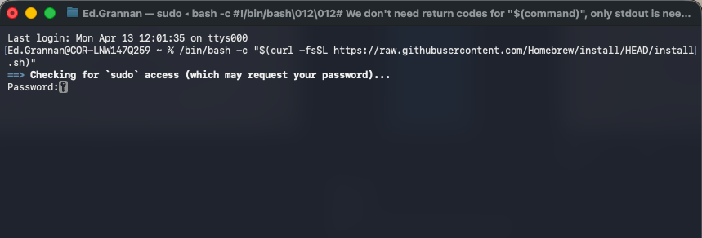
Brew install will ask you to hit enter to continue. Do so. Then do something else, as Brew takes about 15 minutes to install.
Once brew is installed, close terminal and re-open it. You will need a fresh terminal open to have ‘brew’ on your system path.

Git
In a new terminal, type/paste the following command to install Git:
brew install git
This should not request a sudo prompt

Windsurf
In the same terminal or a new one, type/paste:
brew install --cask windsurf
This should not request a sudo prompt

Configure Git
Git requires some configuration. You need to configure your name and email for Git. Open terminal and paste in the following command, then backspace and type to replace Your Name with your actual name (you can’t select text and type over it in terminal).
git config --global user.name "Your Name"
The next command will configure your email address. Use your Improving email address.
git config --global user.email "your.email@improving.com"
Your terminal window should look similar to this when you are done:
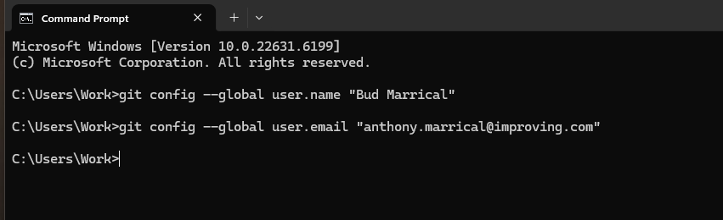

Backup Plan: Visual Studio Code
Unfortunately, several class attendees did not receive their windsurf license before start of the class. If you find yourself in this situation, be prepared to install Visual Studio Code. Windsurf is based on VSC so the two are very similar and you can follow along with the class with only minor differences.
Windows:
winget install -e --id Microsoft.VisualStudioCode
Mac:
brew install --cask visual-studio-code
The morning of your class, if you have not yet successfully logged into Windsurf (instructions above), please try to do so again. If you are still not yet granted a license, install Visual Studio Code so you have it available as a backup.

